Hazard analyses & Risk Assessment
Model: ??
Class of control function: ??

危害或风险Item/  Hazards or risks | 可能的失效模式  Potential Failure Mode(s) | 可能产生的影响  Potential Effect(s) of Failure | 原因分析  Potential Cause(s) | 结果 result
 |  |  |  | 安全等级Severity | 可能性Probability | 安全等级×可能性  Severity× Probability
Electric shock
EMC immunity
Water immersion
External shot-circuit
Internal shot-circuit
Overcharge
Overheating
Drop
Crush
Overdischarge
Discharge with overcurrent
Charge after an overdischarge
Electrolyte leakage
Ignition of emission gas
Fire
Earthquake
Seismic sea wave
危害或风险Item/  Hazards or risks | 优化措施Mitigation measures |  |  | 优化后结果 result after mitigation
危害或风险Item/  Hazards or risks |  |  |  | 安全等级  Severity | 可能性  Probability | 安全等级×可能性Severity× Probability
Electric shock | 1.  2.  3.  4.
EMC immunity
Water immersion
External shot-circuit
Internal shot-circuit
Overcharge
Overheating
Drop
Crush
Overdischarge
Discharge with overcurrent
Charge after an overdischarge
Electrolyte leakage
Ignition of emission gas
Fire
Earthquake
Seismic sea wave

可能性：从1到9，9发生的可能性是最大的
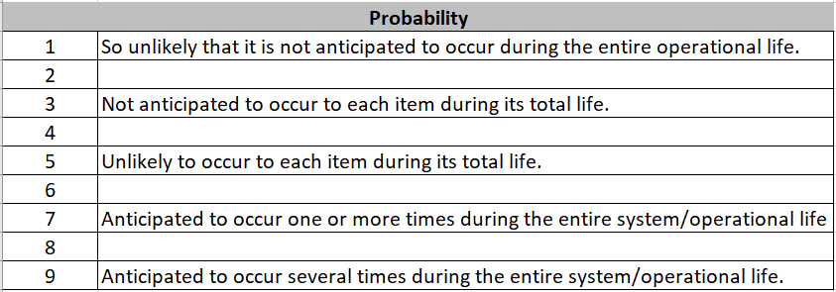

安全等级：从1到9，9是最不安全的
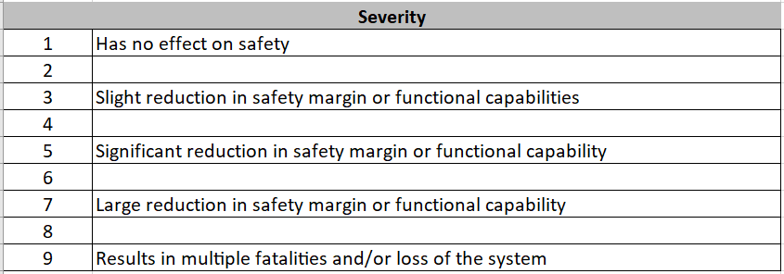
Class B control function:
Failure of the control function will not lead directly to a hazardous situation
失效不会直接导致危险发生的控制功能

Class C control function:
Failure of the control function could directly cause a hazard in the appliance.
失效会直接导致危险发生的控制功能
与Class B的区别，故障累计，更高的DC诊断覆盖率

